Cloud Computing Overview (AWS CLI)

HP03: Interacting with EC2 Part 1

Developed by Marvin Gold 12/17/2020

Reviewed by Kim Nguyen class of 2021

School of Technology and Computing

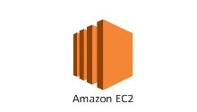

**Learning Outcomes**

* Create a key pair
* Display a key pair
* Delete a key pair
* Create a security group
* Configure a security group
* Delete a security group

**Background**

This week we will start to work with Amazon EC2 through the AWS CLI. The first thing we are going to do is learn how to make, display and delete keys. Then we will learn how to create, configure and delete security groups. Note: please manually type the commands in the HOS, this will help create muscle memory.

**Resources**

<https://docs.aws.amazon.com/cli/latest/userguide/cli-services-ec2-sg.html>

**Step 1: Log onto your Amazon EC2 Instance**

Log onto your Amazon EC2 instance using either OpenSSH, Putty, or from the AWS Management Console using ‘EC2 Instance Connect’ (shown below). Note all IP addresses used in this series of Hands on Skills will be released by the time we start class.

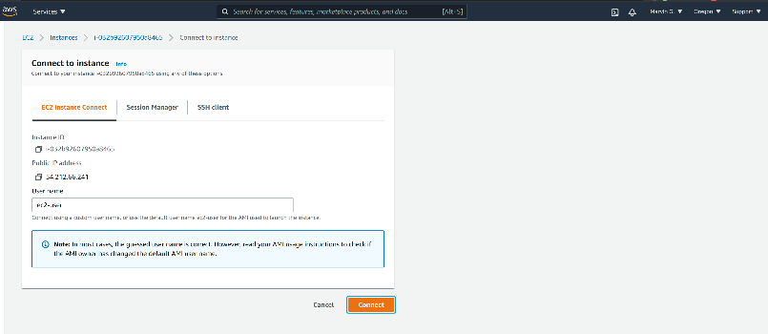

If you receive an error that you must first set your AWS Region and you must configure your AWS CLI, please follow these instructions.

<https://docs.aws.amazon.com/cli/latest/userguide/cli-configure-quickstart.html>  
  
Remember, do not use your root *account* for these operations. You should be using another IAM user. You should not have access keys to your root account.

**Step 2: Create Key Pair**

We use SSH keys to connect to our Amazon EC2 instances and other remote servers. The AWS CLI can create those keys for you. Input the following commands

aws ec2 create-key-pair --key-name MyKeyPair --query 'KeyMaterial' --output text > MyKeyPair.pem

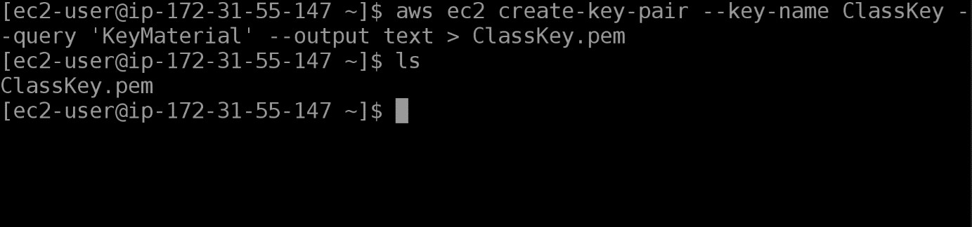

**Step 3: Displaying our Key Pair**

aws ec2 delete-key-pair --key-name MyKeyPairaws ec2 describe-key-pairs --key-name MyKeyPair

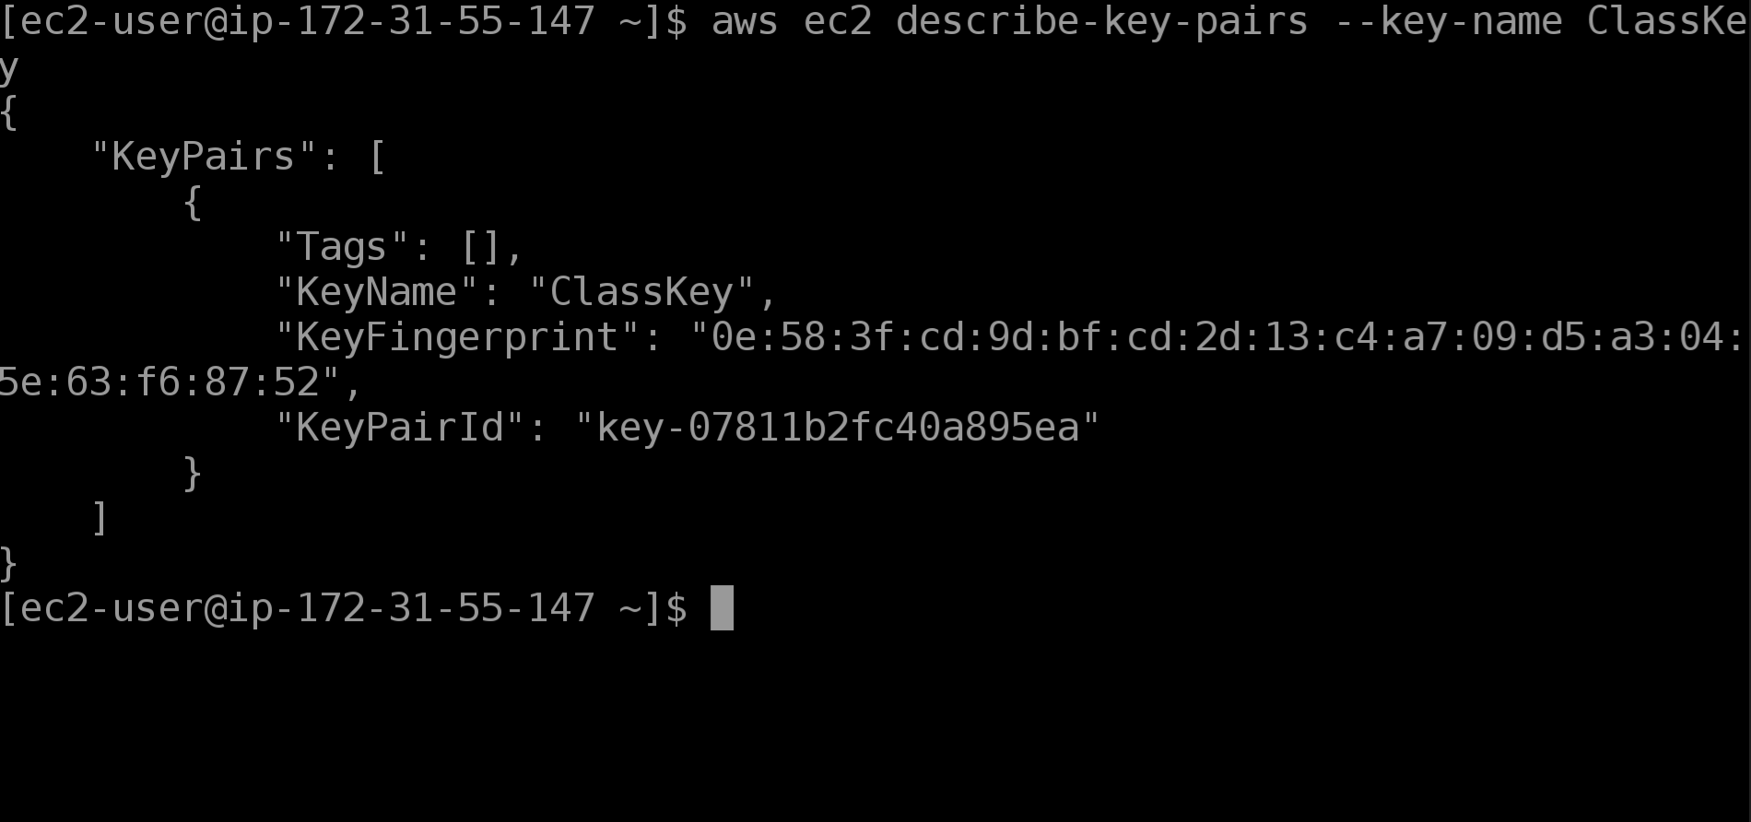

You can use this information to verify your private key matches the your public key on AWS.

**Take a SCREENSHOT of the Keypair you created.**

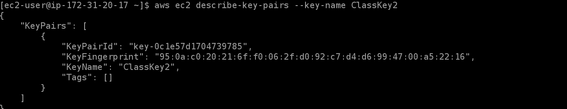

**Step 4: Delete your key pair**

Now we that we have made these key pairs, let’s delete them because we do not need them anymore.

aws ec2 delete-key-pair --key-name MyKeyPair

**Part 2: Security Groups**

Before you begin, you will need to know your VPC ID. To access this, navigate to the Amazon EC2 console. Click on “Instances”, click on your running T2 micro Amazon EC2 Instance. A details pane will pop up, note down your VPC ID you will need it for this section.

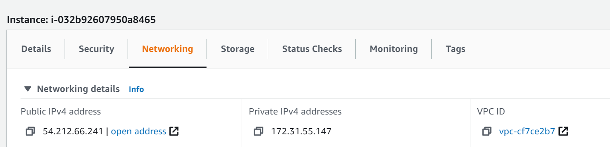

**Step 1: Create a Security Group**

To create a security group we are going to use the ec2 command, ‘create-security-group’

aws ec2 create-security-group --group-name Class-Security-Group --description "My security group for HOP03" --vpc-id <YOUR_VPC_ID_HERE>

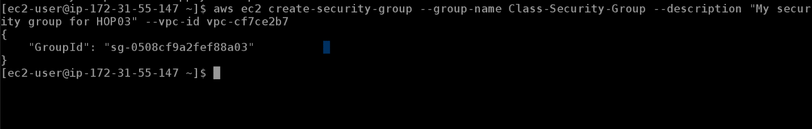

**Take a SCREENSHOT of the output from the above command.**



**Step 2: Describe a Security Group**

Now we have a default security group, let’s see how it is configured. We can use the describe security groups command with the group id option to limit what is returned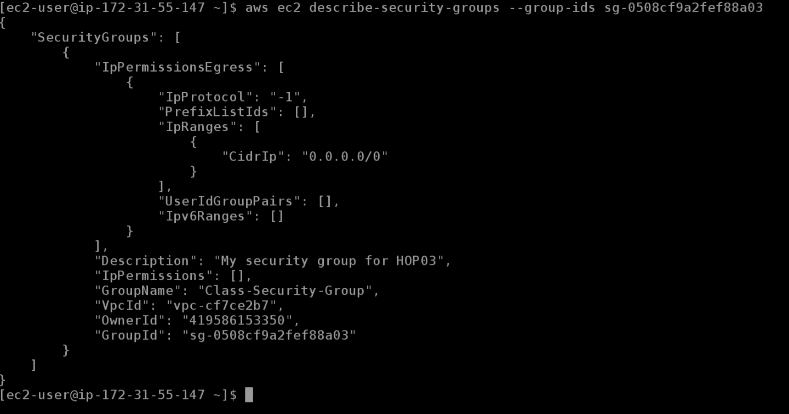

**Question: What does this security group allow?**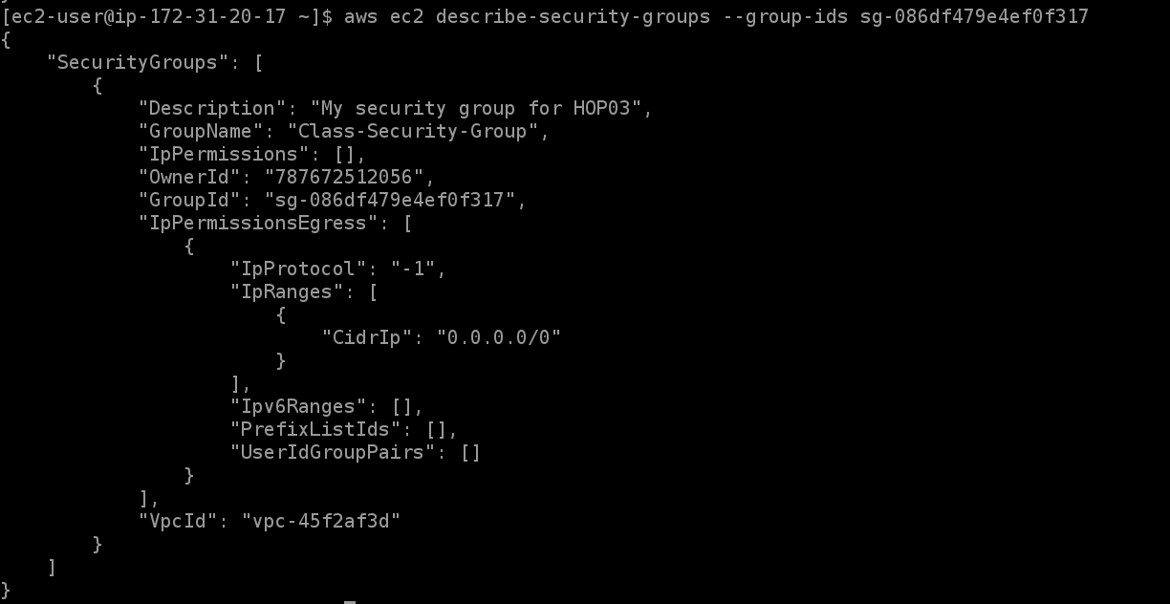

**Step 3: Add Inbound rules**

In order for our security group to allow traffic to the hosts that are part of it, we need to add a rule that allows traffic on specific ports. Let’s add a rule that **allows SSH (22)**, and lets add a rule that **allows HTTPS (8080)** traffic from our IP.

First, figure out what your public IP address is. You have many options. On your Amazon EC2 instance you can use:

curl https://checkip.amazonaws.com

Now we can add a rule to allow us to SSH using the authorize-security-group-ingress command

aws ec2 authorize-security-group-ingress --group-id <YOUR_SG_ID> --protocol tcp --port 22 --cidr <YOUR_PUBLIC_IP>/24

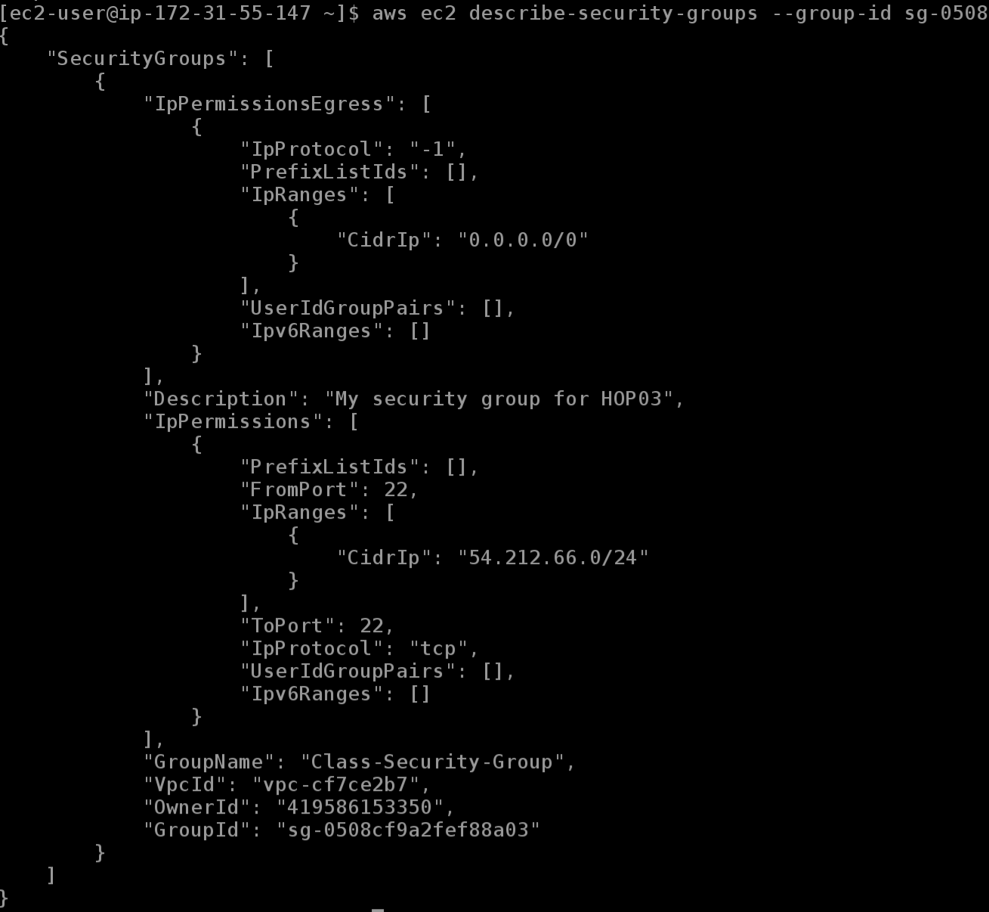

Go ahead and all the rule for HTTPS traffic and describe the security group again!

**Take a SCREENSHOT of your describe-security-groups output.**

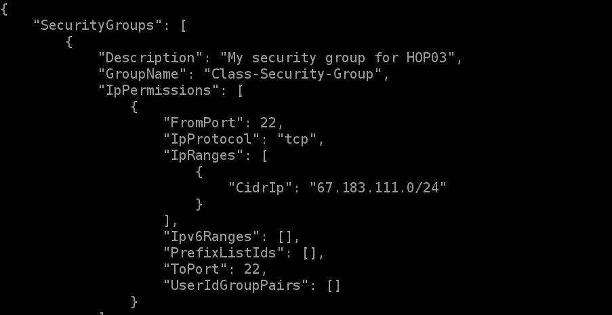

**Step 3: Delete the Security group**

To delete a security group we will use the delete-security-group command, we will pass in the group id.

aws ec2 delete-security-group --group-id <YOUR_SG_ID_HERE>